THE POYNTON CHALLENGE

Sunday morning, June 5, 2022

As part of The Queen's Platinum Jubilee celebrations Poynton Sports Club has organised a walk. The full circular route is 20 miles, although there are options to leave after 7 or 12 miles.
If they wish any walkers can seek sponsorship to raise money for their favourite charity. Alternatively they can just come along on the day to enjoy the hike and the challenge.
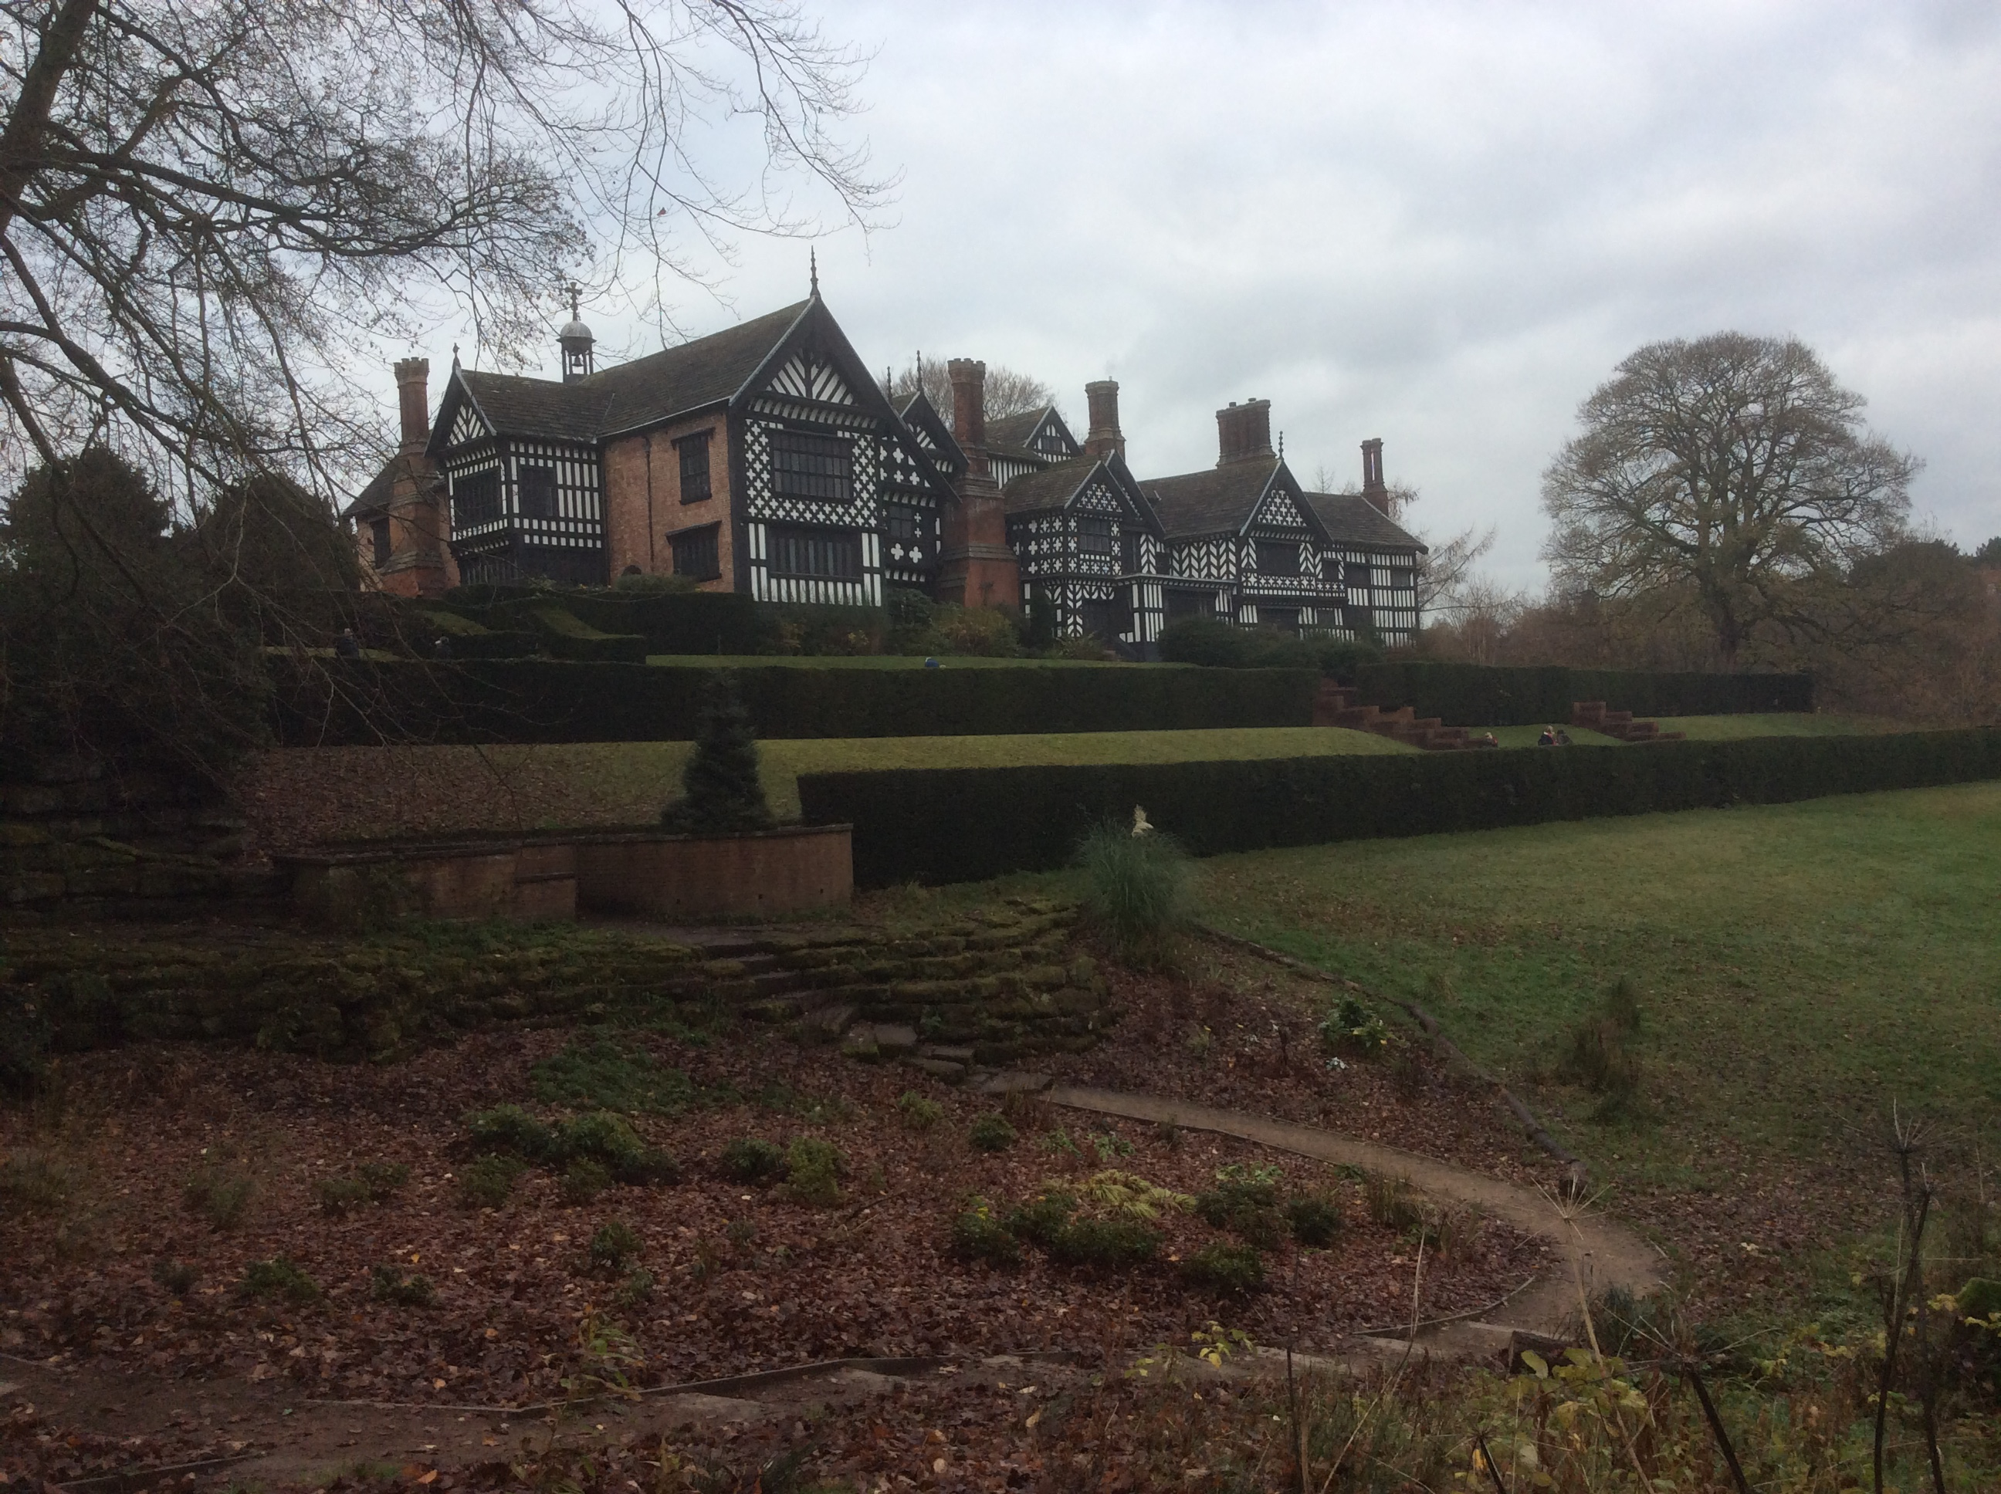

The full route passes Bramall Hall (pictured above) and Lyme Cage (below)

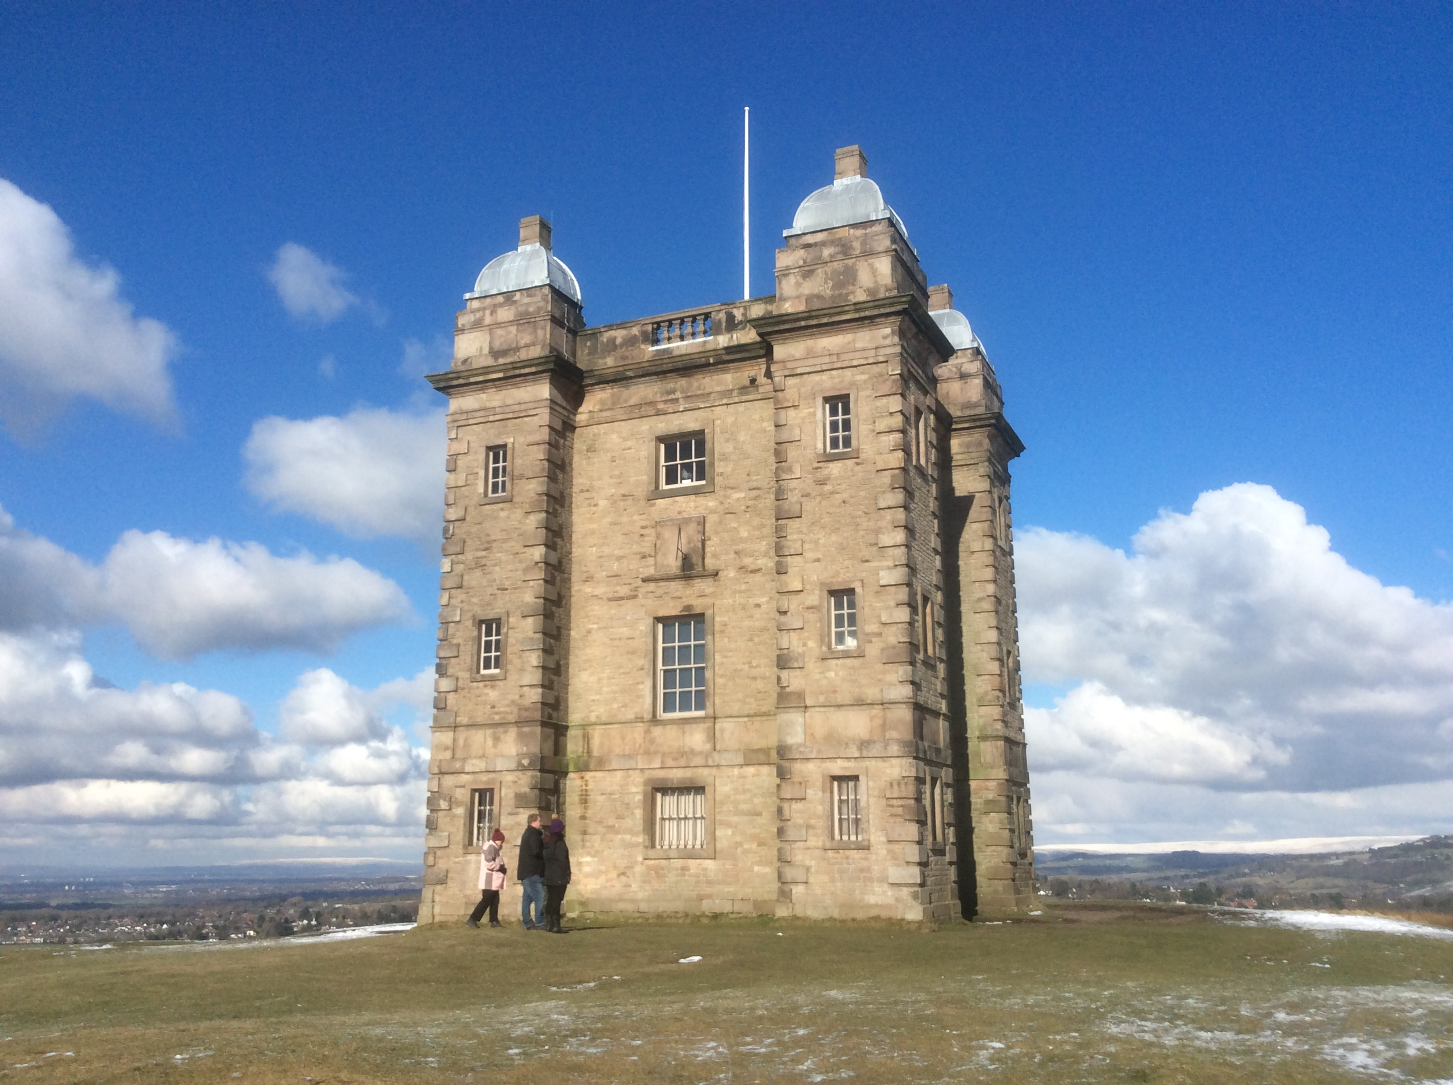

For the most part it will take you to attractive parts of the countryside in and around Poynton.
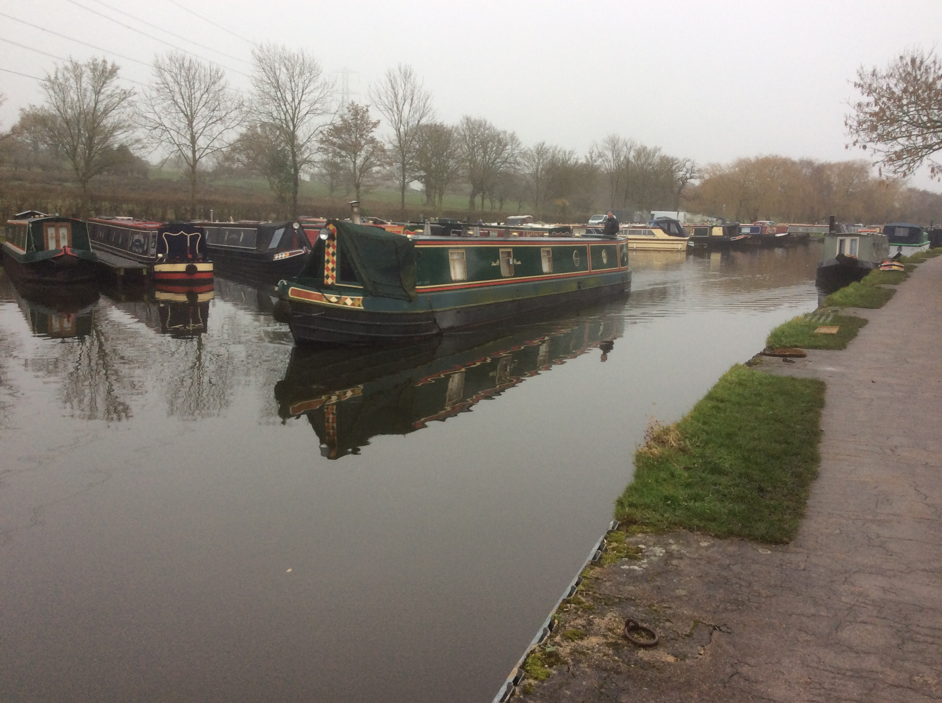
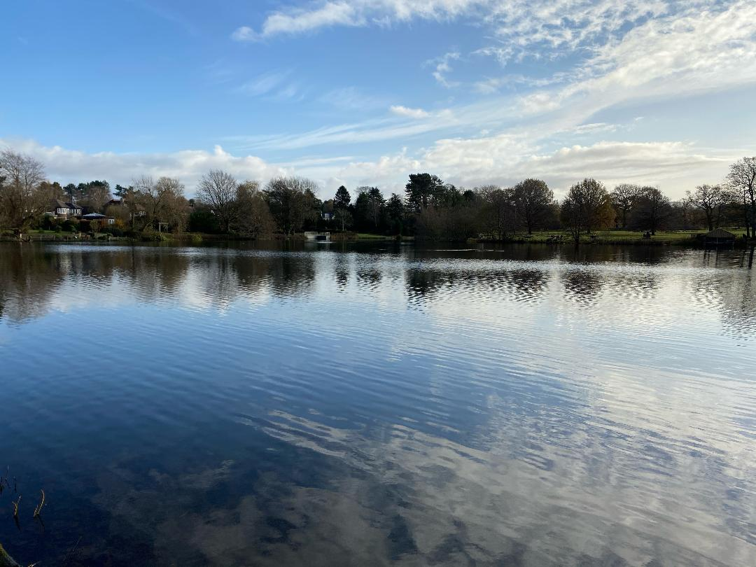

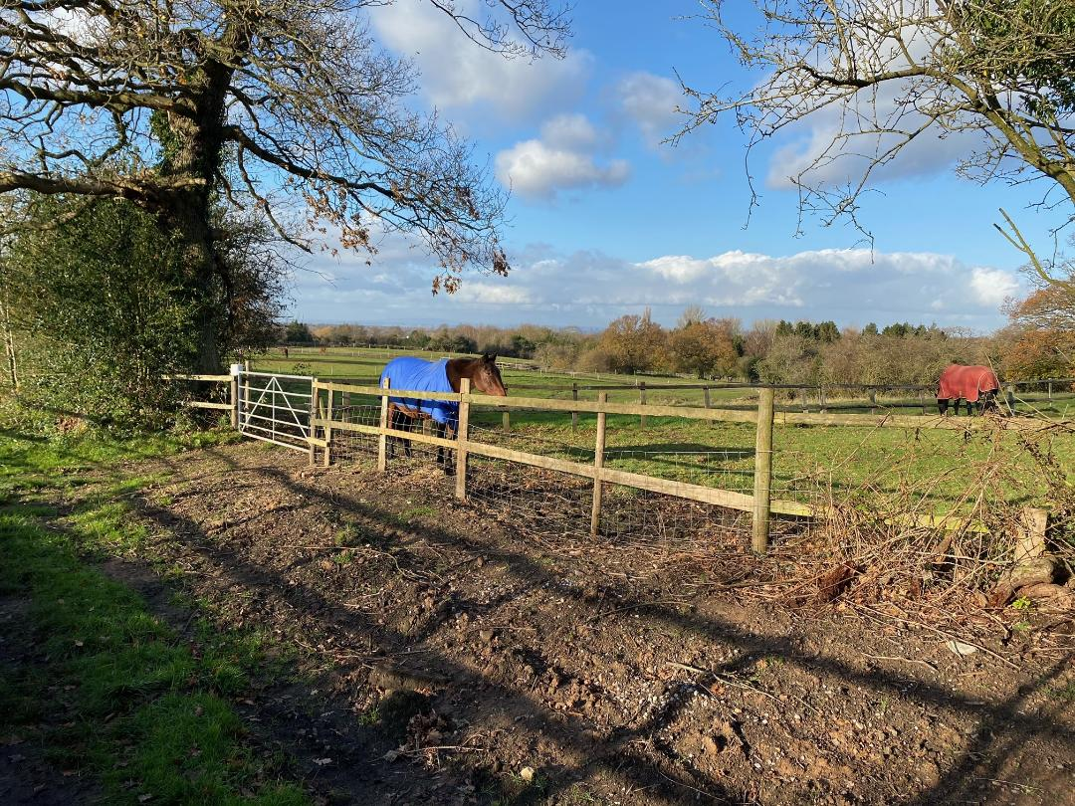

Starting at 9am on June 5 walkers assembling at Poynton Sport Club will be placed in groups of 10 according to kinship, friendship and ability. A leader will be appointed with detailed typed directions and a map of the route. Every ten minutes another group will set off until all walkers are on their way.
There are public toilets at Bramall Hall, at Lyme Park and Nelson's Pit Museum, Higher Poynton, which are on the route and marked on your map.
You are advised to carry plenty of water, food for your journey and an emergency blister pack. There may be muddy areas on the walk and boots are recommended.
Dog walkers are welcome but there is a farmer's field en route which may contain cows with calves. Details of how to detour this field are given in your directions.
Alan Hart (Organiser)

